Transaction Scenarios

Step 1 — Create Vendor Invoice
Form path
Accounts Payable → Invoice Journal
Description
Vendor invoices were entered in the system including:
• Vendor account
• Invoice date
• Invoice amount
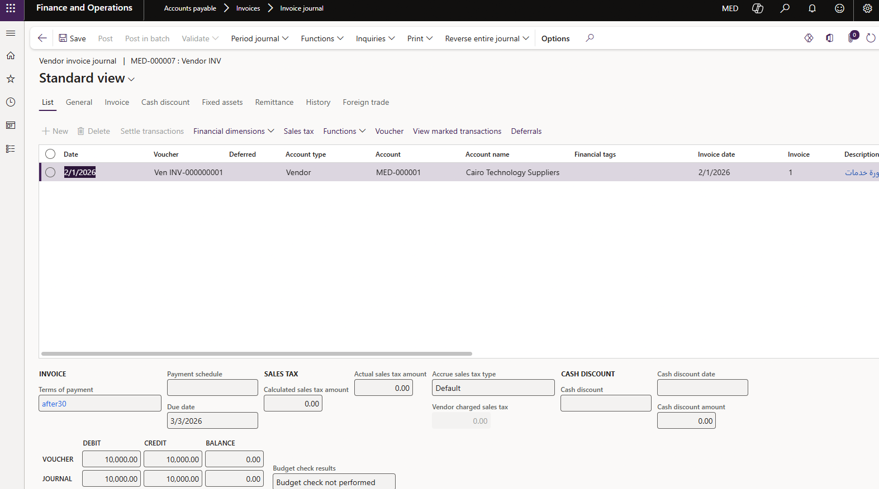

Step 2 — Post Vendor Invoice
Description
After validation, invoices were posted to the ledger.
The system automatically recorded the liability to the vendor.

Step 3 — Vendor Payment
Form path
Accounts Payable → Payment Journal
Description
Vendor payments were recorded to settle outstanding invoices.
Payment scenarios included:
• Full payment
• Payment with cash discount
• Payment schedules
